PABSON SHIVRAJ
1st Terminal Examination 2081
Class :9 Subject: Science (Set A) F. M. 75
Time : 3 hrs
Group A
Circle the correct answer to the following questions.
10x1=10
a. What is the coefficient of Giga prefix?
i) ${10}^{9}$ ii) ${10}^{10}$ iii) ${10}^{11}$ iv) ${10}^{12}$
b. The veterinary profession is associated with
i) Physics ii) Biology iii) Chemistry iv) Geology
c. Who introduced the binomial system of nomenclature ?
i) Carolus Linnaeus ii) R.H Whittaker
iii) Chatton iv) Robert Koch
d. Which of the following kingdom belongs to eukaryotic
unicellular organisms ?
i) Fungi ii) Protista iii) Monera iv) Animalia
e. Which mushroom is used to make medicine for the treatment
of cancer?
i) Red mushroom ii) Dalle Mushroom
iii) Kanya mushroom iv) Gobre mushroom
f. Which part of mushroom produces basidiospores ?
i) Stipe ii) Vulvla iii) Annulus iv) Gills
g. Fossils are found in which rock ?
i) Igneous rock ii) Sedimentary rocks
iii) Conglomerate iv) Metamorphic rock
h. What is the scientific name of all human beings ?
i) Monkey ii) Chimpanzee
iii) Homo sapiens iv) All of the above
i) Cardiac muscle tissue is found in ……..
i) Stomach ii) Heart iii) Kidney iv) Pancrease

j) Which of the following tissue has the capacity of cell division?
i) Complex tissue ii) Connective tissue
iii) Meristematic tissue iv) Permanent tissue

Group B
Answer the following questions briefly. 9x1=9
1. Write any two branches of science .
2. Who is the father of biology?
3. What is the scientific name of leopard .
4. Define binomial system of nomenclature .
5. What is the kingdom of Mushroom ?
6. What is evolution ?
7. What is fossil ?
8. What is cell ?
9. What is nervous system?
Group C
Write short answer to following questions 14x2=28
1. Write two precautions to be taken during science
practical.
2. Write any two advantages of scientific notation .
3. Find the least count of following device.
i) Scale ii) Protactor
4. Why living beings must be classified ?
5. Why five kingdom system is more suitable & scientific
than the two kingdom system ?
6. Draw a labelled diagram of structure of mushroom.
7. The person with high blood pressure, diabetes & heart
disease are encouraged to have mushroom Why ?
8. Write two differences between edible &poisonous
mushroom.
9. Who is the founder of theory of "survival of the fittest"?
Clarify the meaning of this theory with example.
10. What are the vestigial organs? Give two examples.
11. Give two differences between mutation & variation .
12. Human reaches to Coma when the cerebrum gets injured
. Give reason.
13. Write differences between xylem & phloem.
14. What is nervous tissue? Write down its functions.
Group D
Answer the following questions in detail . 7x4=28
1. Write down the rules of scientific notation with example .
2. Write two achievements & Challenges of science & technology
for each in the field of education & health .
3. Prepare a chart of classification of five kingdom system two
examples of each.
4. Ram is vegetarian. He went to market to buy a mushroom & he found it expensive so he decided to do mushroom farming at home . Suggest him the process of doing it .
5. Describe the lifecycle of mushroom with diagram.
6. What is reflex action? Describe with an example .
7. Study the diagram & answer the following questions.
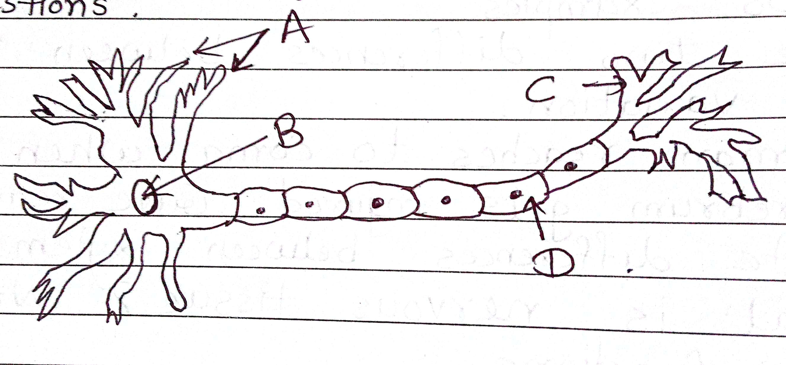

i)Identify the figure .
ii) Name the label A, B, C & D .
iii) Write the functions of parts A,B,D

Best of luck

